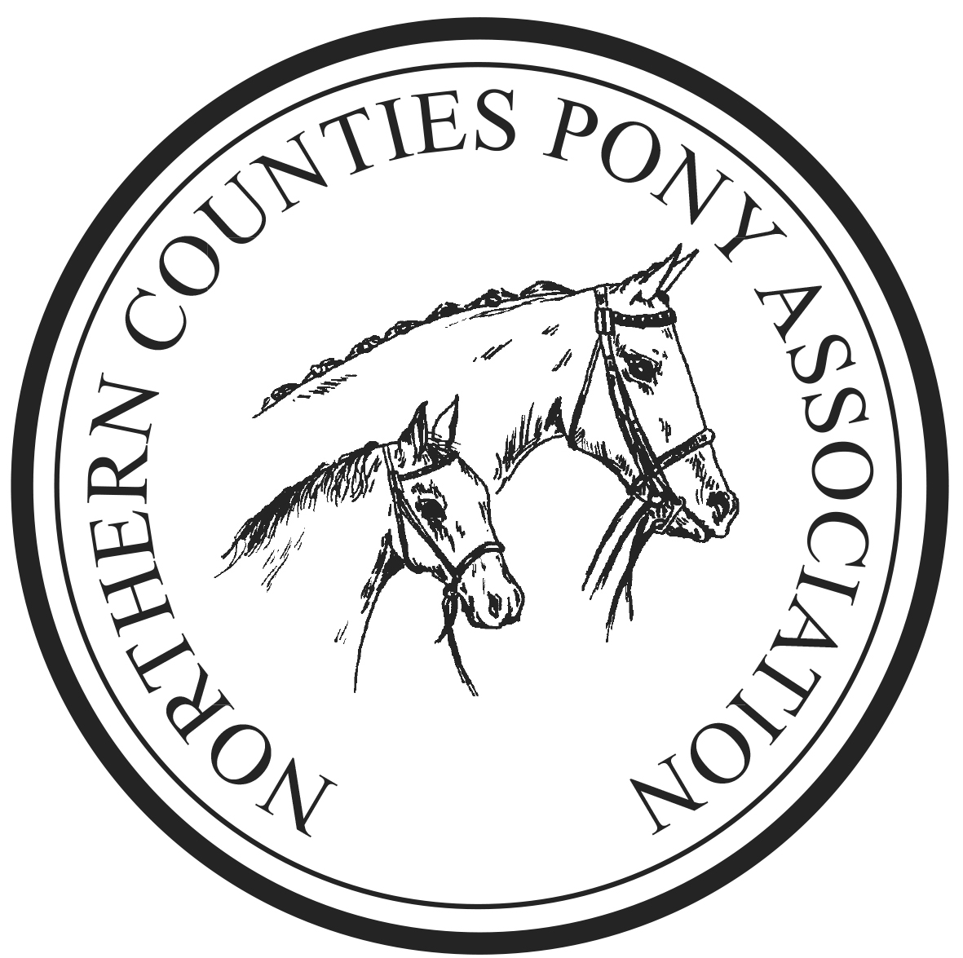

STAFFORDSHIRE BRANCH

WWW.NCPA-STAFFS.COM

SPRING FESTIVAL
SHOW

Qualifier for NCPA Pony of the Year 2025

NPS Spring Festival 2025

RIHS Young & Amateur Riders Mountain & Moorland Final 2025

Saturday 12th April 2025

Hosted at -

Pickering Grange,
Ellistown Terrace Road,
Ellistown,
Leicestershire,
LE67 1EZ.

Stabling available book directly with the venue

Entries close 9th April via entrymaster, on the day can be taken but at a higher rate and cash only.

STRICTLY NO LUNGING

Show Secretary

Mrs Cheryl Scott Tel: 07966 625994


(Registered Charity No. 264796)

RULES

1 The Judges decision is final.
2 The committee accept no responsibility whatsoever for loss, injury or damage to any person or their
property whilst on the Showground.
3 NO nomination or substitute entries will be accepted.
4 NO entry fee will be refunded.
5 The committee reserves the right to amend the schedule and to refuse entries at their discretion.
6 Objections to be lodged in writing within 30 minutes of the event, with a deposit of £50, which will be
returned if the objection is upheld.
7 Anyone found to be abusive in any form will be excluded from the show ground.
8 A rosette will be awarded to the highest placed Staffordshire Branch Member in every class, gold
armbands must be worn.
9 Anyone found mistreating a horse or pony will be asked to leave the showground, and reported to the
appropriate body.
10 ANY PONY TAKING PART IS LIABLE TO DOPE TESTING
11 Any stallions or colts must be led or ridden by an attendant/rider of 14 years old and over.
12 ALL riders must be suitably mounted.

NPS Winter Championship Qualifying Rounds
This show is affiliated to the National Pony Society and the NPS affiliated classes will be run under NPS rules. Classes are open to Members and Non-Members of the NPS, but Non-Members will need to become members to enter the finals at the NPS Spring Festival 2025.

The NPS General Rules for Showing apply (see NPS website for details).
In each class the three highest placed ponies, not already qualified, within the first six places, will qualify. Winnings in the 2024/2025
Novice and Pure Novice Winter Championships will not debar ponies from the NPS 2025 Mountain and Moorland Novice Ridden competitions. Qualification cards will be awarded in the ring.
.
HEALTH AND SAFETY
The organisers will take any necessary precautions to ensure the Health and Safety of persons on the Showground. It is a condition of entry to the Showground that all persons will act on any instructions given to them by the show committee, in so far that it can effect the health and safety of all. All competitors must take due care to section 7 of the Health and Safety Act and have due regard for the safety of others. There is a Health and Safety Statement on display at the Secretary’s Office.
Dogs must be kept on leads at all times. Horses must not be left tied to horse boxes.

Entry Fees: All entries are via Entry-master & include first aid.
Closing Date Wednesday 9th April 2025.
In-Hand Classes, £12 Members & £15 non-members,
Ridden Classes £17 Members & £20.00 non-members,
RIHS £35 members and £40 non-members (including the RIHS Levi @ £12)
Prize money of £25 for class winners in RIHS classes
Entries will be taken on the day, £10 extra on the day for all classes bar RIHS
£20 extra for RIHS classes – CASH ONLY

Clashing of Classes.
Whilst every endeavour has been made with the timetable to accommodate everyone, clashing is sometimes unavoidable. Therefore, classes will not be held up - so please bear this in mind when entering, as entry fees are not refundable.
It is recommended that every animal at the show has third party insurance

** This show is a qualifier for the N.C.P.A. Pony of the Year Show
First, second, and third prize winners in appropriate classes will qualify **
Also a qualifier for NCPA TOPLINE HORSEBOXES Junior Mountain & Moorland Pony of the Year the highest placed juniors in classes 3 to 8 will qualify.

“This Show is a qualifier for the NPS Area 4 In Hand Final sponsored by “Gowland Plumbing Services”. The Champion and Reserve Champion from the Riding Pony Breeding, Hunter Pony Breeding and Mountain & Moorland In Hand Classes will qualify for the Final to be held on Monday 25th August 2025 at the NPS Area 4 Summer Show. Qualifiers do not have to be Members of the NPS.

Indoor Ring 1 Commencing 9am Judge: Mr A Cooper

Unaffiliated Classes

Class 1 Walk and Trot Class: Only walk and trot allowed in this class. Animals any height, any breed, any type. Riders any age.
Class 2 Novice Rider Class: any horse/pony to be ridden by a rider not to have won a 1st prize before 1st January.

Not Before 10am

NPS M&M PURE NOVICE RIDDEN WINTER CHAMPIONSHIP

This Competition is open to stallions, mares and geldings four years old or over which must be registered in the main body of their respective Mountain & Moorland Stud Book.
Pony not to have been placed first in any Ridden Mountain & Moorland Class (excluding Lead Rein or First Ridden) before 1st September in the current season All ponies in this class must be shown in a snaffle bit. Rider any age (except stallions – see NPS Rules).

Class 3 Dartmoor, Exmoor, Shetland, Welsh A & B
Class 4 Connemara, Dales, Fell, Highland, New Forest, Welsh C & D

NPS/CASTLEFORD STUD M&M CONFINED NOVICE RIDDEN WINTER CHAMPIONSHIP

This Competition is open to stallions, mares and geldings four years old or over which must be registered in the main body of their respective Mountain & Moorland Stud Book. Pony not to have won a first prize of £10 or more in any open Ridden M&M Class before 1st September in the current season. Rider any age (except stallions – see NPS Rules)

Class 5 Dartmoor, Exmoor, Shetland, Welsh A & B
Class 6 Connemara, Dales, Fell, Highland, New Forest, Welsh C & D

Championship for the 1st and 2nd prize winners from classes 3-6

Not before 12pm

RIDDEN WINTER CHAMPIONSHIP NPS/CE FULLER & SONS M&M OPEN

This Competition is open to stallions, mares and geldings five years old or over which must be registered in the main body of their respective Mountain & Moorland Stud Book. Rider any age (except stallions – see NPS Rules).

Class 7 Dartmoor, Exmoor, Shetland, Welsh A & B
Class 8 Connemara, Dales, Fell, Highland, New Forest, Welsh C & D

Championship Open to the two highest placed ponies from classes 7-8

Not Before 1pm Judge : Mrs H Turnock

UK PONIES & HORSES LIMITED & ANTHONY EVANS INSURANCE BROKERS

RIHS YOUNG RIDERS MOUNTAIN & MOORLAND RIDDEN FINAL 2025
RIHS AMATEUR RIDERS MOUNTAIN & MOORLAND RIDDEN FINAL 2025
TO BE HELD AT THE ROYAL INTERNATIONAL HORSE SHOW, HICKSTEAD, WEST
SUSSEX, RN17 5NU IN JULY 2024.

TO BE JUDGED IN ACCORDANCE WITH THE RULES OF UK PONIES & HORSES LIMITED.
Owners must be Adult / Life Members, Riders must be current UK Ponies & Horses Limited Annual
Members and the ponies currently registered with UK Ponies & Horses Limited before time of entry in
order to compete in these classes
Open to Mountain and Moorland Ridden Stallion (Intermediate class only), Mare or Gelding, 4 years old
and over.
Registered in their approved Pure Breed Society Stud Books of Connemara, Dartmoor, Dales, Exmoor,
Fells, Highland, New Forest, Shetland, Welsh A, B, C or D.
The highest placed exhibit not already qualified within the first five will qualify for the UK Ponies &
Horses Limited RIHS Young Riders M&M Ridden.
The highest placed pony and rider not already qualified within the first five will qualify for the UK Ponies
& Horses Limited RIHS Amateur Riders M&M Finals at the RIHS Hickstead in July 2025. Qualification will be verified by the office. Only 1st & 2nd prize winners from the Large Breeds, Small Breeds & the Intermediate Section will be eligible for the UK Ponies & Horses Limited Championship. All three
sections must be included in the Championship.

Class 9 RIHS UK Ponies & Horses Limited & Anthony Evans Insurance Brokers Intermediate M&M – Stallion, Mare or Gelding, 4 years old & over. Registered in their approved Pure Breed Society stud books of Connemara, Dales, Dartmoor, Exmoor, Fells, Highland, New Forest, Shetland, Welsh Section A, B, C or D. Rider not to have attained their 25th Birthday before the 1st January in the current year. (See Rule 7 of the current UK Ponies & Horses Limited Rule Book).

Class 10 RIHS UK Ponies & Horses Limited & Anthony Evans Insurance M&M Large Breeds –
Mare or Gelding, 4 years old & over Registered in their approved Pure Breed Society stud
books of Connemara, Dales, Fells, Highland, New Forest, Welsh Section C or D.
Rider not to have attained their 18th Birthday before the 1st January in the current
year.

Class 11 RIHS UK Ponies & Horses Limited & Anthony Evans Insurance M&M Small Breeds –
Mare or Gelding 4 years old & over Registered in their approved Pure
Breed Society stud books of Dartmoor, Exmoor, Shetland, Welsh Section
A or B. Rider not to have attained their 14th Birthday before the 1st January
in the current year.

Championship for the 1st & 2nd prize winners from classes 9-11

Class 12 RIHS UK Ponies & Horses Limited& Anthony Evans Insurance Amateur Rider Ridden M&M – Mountain and Moorland ridden Stallion, Mare or Gelding 4 years old and over, registered in their approved Pure Breed Society stud Books of Connemara, Dartmoor, Dales, Exmoor, Fells Highland, New Forest, Shetland , Welsh A,B.C,D rider any age.
UK Ponies & Horses Limited Mini Juniors – Mountain & Moorland Small Breeds
only, registered in their approved Pure Breed Society Stud Books of Dartmoor, Exmoor,
Shetland, Welsh Section A or B. Mare or Gelding 4 years old or over. Riders to have attained
their 8th birthday but not their 13th birthday before the 1st of January in the current year.
Combinations would not be required to become a Member of UK Ponies Horses to compete in this class.

Ring 2 Commencing 9am prompt Judge: Mrs A Monson

NPS M&M IN-HAND CHAMPIONSHIP

This Competition is open to Mountain & Moorland ponies registered in the main body of their respective Mountain & Moorland Stud Books. At Foal Shows, the first three ponies in each class will qualify for the Yearling Final at the Spring Festival.

Class 13 Welsh Sec A & B, Shetlands, Dartmoor, Exmoor, Yearling, 2 and 3 years old Colt, Filly or Gelding
Class 14 Welsh Sec A & B, Shetlands, Dartmoor, Exmoor, 4 years and over, Stallion, Mare or Gelding
Class 15 Welsh Sec C & D, New Forest, Connemara, Dales, Highland, Fell, Yearling, 2 and 3 years old Colt, Filly or Gelding
Class 16 Welsh Sec C & D New Forest, Connemara, Dales, Highland, Fell,4 years and over, Stallion, Mare or Gelding
Class 17 Best Turned Out: To be judged on the combined turnout of animal and handler.
Class 18 Best Condition non M&M In Hand: Colt, filly, stallion, mare or gelding.

Championship – 1st and 2nd prize winners compete from classes 13-18

Not Before 10.30am

NCPA Registered Judge: Mrs A Monson

NCPA registered Mountain & Moorland Pony to be on the NCPA register, and pony's NCPA registered number quoted on the entry form. Pink Card to be produced in the ring.

Class 19 NCPA Registered non M and M young stock 3 years old and under. Pink Card to be produced in the ring
Class 20 NCPA Registered non M and M adult 4 years old and over. Pink Card to be produced in the ring
Class 21 NCPA Registered M and M in hand young stock, open to large and small breeds. Pink Card to be produced in the ring
Class 22 NCPA Registered M and M in hand any age, open to large and small breeds. Pink Card to be produced in the ring

Championship Open to 1st and 2nd prize winners from 19 - 22

Class 23 Unaffiliated Open in hand any age, horse or pony.
Class 24 Unaffiliated M and M in hand any age, open to large and small breeds. Pink Card to be produced in the ring.

Indoor Ring 2 Commencing 1pm Judge : Mr A Cooper

NPS WILLIAMS & NASH MEMORIAL M&M NOVICE LEADING REIN WINTER CHAMPIONSHIP

Class 25 This Competition is open to mares and geldings four years old or over, registered in the main body of their respective Mountain and Moorland Stud Book. Not exceeding 122cms.
Pony not to have won a first prize in any Leading Rein class before 1st September in the current season. To be shown in a snaffle bit, the leading rein must be attached to the noseband only. The reins must go directly from the bit to the rider’s hands.
Riders must not have attained their 9th birthday by 1st January in the current year.

NPS/WILLIAMS & NASH MEMORIAL M&M NOVICE FIRST RIDDEN WINTER CHAMPIONSHIP. Kindly sponsored by NPS AREA 25

Class 26 This Competition is open to mares and geldings four years old or over, registered in the main body of their respective Mountain and Moorland Stud Book. Not exceeding 128cms.
Pony not to have won a first prize in any First Ridden class before 1st September in the current season. Ponies must not be cantered except in their individual show.
Riders must not have attained their 12th birthday by 1st January in the current year.

Judge: Mrs A Monson

NPS/M&M LEADING REIN WINTER CHAMPIONSHIP

Class 27 This Competition is open to mares and geldings four years old or over, registered in the main body of their respective Mountain and Moorland Stud Book. Not exceeding 122cms.
To be led by an attendant and shown in a snaffle bit, the leading rein to be attached to the noseband only. The reins must go directly from the bit to the rider’s hands.
Riders must not have attained their 9th birthday by 1st January in the current year.

NPS/M&M FIRST RIDDEN WINTER CHAMPIONSHIP

Class 28 This Competition is open to mares and geldings four years old or over, registered in the main body of their respective Mountain and Moorland Stud Book. Not exceeding 128cms.
Riders must not have attained their 12th birthday by 1st January in the current year.

Mini Championship Open to the 1st and 2nd prize winners from classes 25-28

Not Before 2.30pm Judge : Mr A Cooper

Class 29 Novice Pony Class: any type not to have won a 1st prize before 1st January.
Class 30 Novice Show Horse: Any Type Mare or Gelding, 4 years old and over exc. 148cms
Class 31 Open Pony Class: any type.
Class 32 Open Show Horse: Any Type Mare or Gelding, 4 years old and over exc. 148cms
Class 33 NCPA Registered non M&M Stallions, mares & geldings, 4 yrs old & over, riders any age inc Lead-rein, 1st prizewinner qualifies for the Chairman’s cup & NCPA registered supreme finals. Pink Card to be produced in the ring
Class 34 NCPA Registered M&M Large Breeds, Stallions, mares & geldings, 4 yrs old & over, riders any age. 1st prizewinner qualifies for the Chairman’s cup & NCPA registered supreme finals. Pink Card to be produced in the ring
Class 35 NCPA Registered M&M Small Breeds, Stallions, mares & geldings, 4 yrs old & over, riders any age. 1st prizewinner qualifies for the Chairman’s cup & NCPA registered supreme finals. Pink Card to be produced in the ring

Championship for the 1st & 2nd prize winners from classes 29-35

Dates for your Diary

NCPA Staffordshire Country Festival
5th & 6th July 2025 @ Pickering Grange

NCPA PONY OF THE YEAR
14th September 2025@ Warren Farm

