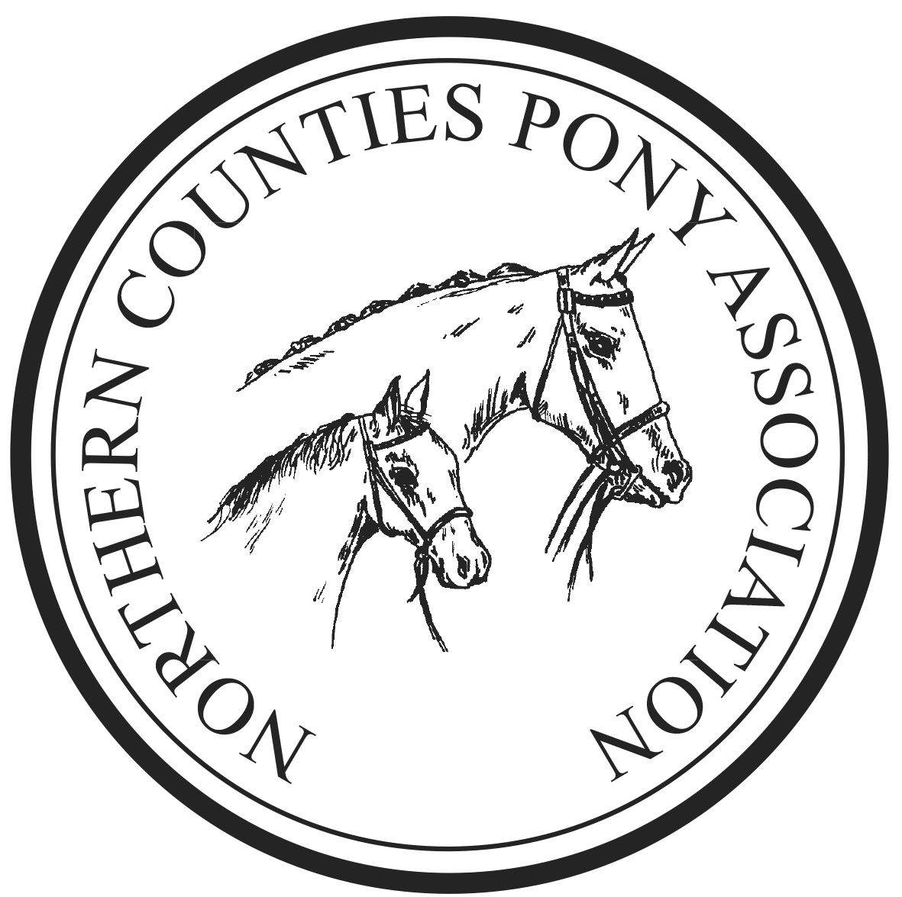NCPA YORKSHIRE BRANCH
SUMMER SHOW

Sunday 1st June 2025

MILL LANE STABLES, MILL LANE,

BRAYTON, Nr SELBY, YO8 9LB

Online Pre entries Postal entries MEMBERS ONLY
Online Close 21st May at cheaper rate & Thursday 29th at £5 increase fee
POSTAL ENTRIES NCPA MEMBERS ONLY CLOSE 10th May
Entries on the day EXACT CASH ONLY £25

NCPA affiliation number (92/25)

Qualifiers for the 2025 NCPA GOLDEN SUPREMES
Prize monies at the final £500, £300, £100, £50, £25, £25 for each

**This show is a qualifier for the N.C.P.A. Pony of The Year held in September 2025. First, second & third prize winners in appropriate classes will qualify. **

**This show is a qualifier for the N.C.P.A. GOLDEN SUPREMES held in September 2025. ALL In Hand Champion & Reserve prize winners will qualify plus 1st prizewinners in ridden classes. **

Show Secretary:
Mrs J K Bushell
11 Mawdsley Close, Formby
Tel : 01704 834482
gensec@thencpa.co.uk

Rules of Entry
When entering a pony / horse it is a condition of entry that these rules are abided by.
- It is the exhibitors’ responsibility to ensure they are present in the ring at the start of the class.
- Refunds of class fees will not be given if exhibitors miss their class.
- The Judges decision is final.
- The judge may withhold any prize where there is an evident want of merit.
- Riders of stallions must be aged 12 years + for small breeds and 14 years + for large breeds.
- Objections – Any objections to be made in writing to the Secretary with a deposit of £30.00 cash, which will be returned if the objection is upheld. All objections must be made within 30 minutes of the class taking place.
- The Officials and Council of the NCPA accept no responsibility for loss, injury or damage to any person or their property whilst on the Showground, car parks or approaches. All entries are subject to these conditions.
- Exhibitors alone are solely responsible for the accuracy and eligibility of their entries. No entry will be accepted unless accompanied with the correct fee. In the event of an entry proving incorrect, (whether by mistake or otherwise), the entry fee will not be returned.
- An Exhibitor may not exhibit a pony / horse bred, sold, leased or produced by the Judge, their immediate family or their employer.
- The Committee reserves the right to expel from the class or Showground any animal not considered to be under control, especially where a danger to the public could be created.
- The Committee reserves the right to cancel, amalgamate or divide any class should entries so warrant.
- No substitute or nomination entries will be allowed.
- In the event of the Show being cancelled by events beyond our control, a £5.00 administration fee will be deducted from each Exhibitor.
- All persons entering the Showground must have personal third party insurance.
- This Show operates under the NCPA Child and Vulnerable Persons Protection Policy.
- Show canes and whips must not be more than 30 inches long.
- Ponies / horses must leave the ring at walk.
- Correctly secured BSI skull caps/riding hats accredited to the latest approved standards must be worn at all times when mounted.
- Lead Rein Classes: Ponies to be shown in a snaffle bridle and the lead rein to be attached to the nose band on which it must remain whilst the pony is in the ring. Whilst in the ring, the pony must be led at all times.
- First Ridden Classes: Ponies to be shown in a suitable bridle. No cantering allowed except for individual show.
- Mountain and Moorland ponies must be shown in their natural state and must be registered with their respective Breed Society, and the registration number quoted on the entry form.
- All Stallions and Colts must be licenced as stipulated by their relevant breed society and must handled by a person over 14 years of age and be adequately bitted and under control.
- No litter to be left on the Showground. CLEANING OUT HORSEBOXES & TRAILERS IS STRICTLEY FORBIDDEN.
- All Exhibitors must be wearing the allocated number for the Exhibit when entering the ring;
- Dogs must be on a lead and supervised at all times.
- Handlers and Grooms must be appropriately dressed.
- Anyone found to be mistreating a horse or pony may be asked to leave the show ground, and reported to the appropriate body.
- All horses and ponies must have a valid passport which should accompany the animal on show days.
- Handlers in In-Hand classes ages 14 years and under, must wear a correctly secured current British Standard skull cap or riding hat
- Exhibitors must have Public Liability Insurance when competing at NCPA events.

Online pre entries:
NCPA Members: £10 Postal £12
Non NCPA members: £15
First Aid £3.00 per rider/handler
NCPA *Star rosettes: Classes 4, 16, 19, 37 & 50 NCPA +Register Rosettes: Classes 10, 24 & 42
ALL ENTRIES ON THE DAY: £25 CASH ONLY (exact money)

THE COMMITTEE WOULD LIKE TO SAY A HUGE THANK YOU TO ALL OUR SPONSORS AND HELPERS

RING 1 IN HAND 9.30am Judge: Ms D Smith

1 Welsh A & B: Stallion, Mare or Gelding 4 years old and over
2 Welsh A & B: Colt, Filly or Gelding 3 years old and under
3 Dartmoor, Exmoor & Shetland: Stallion, Mare or Gelding 4 years old and over.
4 Dartmoor, Exmoor & Shetland: Colt, Filly or Gelding 3 years old and under.
5 Welsh C & D: Colt, Filly or Gelding 3 years old and under.
6 Welsh C & D: Stallion, Mare or Gelding 4 years & over.
7 Connemara, Dales Fell, Highland, New Forest: Colt, Filly or Gelding 3 years old and under.
8 Connemara, Dales, Fell, Highland, New Forest: Stallion, Mare or Gelding 4 years & over.
Championship 1st & 2nd prize winners from classes 1 – 8

NCPA REGISTERED IN HAND (NCPA Reg.No. to be quoted)
9 NCPA Registered Small M&M Breeds: Stallion, Mare, Colt, Fillies or Geldings any age
10 NCPA Registered Large M&M Breeds: Stallion, Mare, Colt, Fillies or Geldings any age
11 NCPA Registered NON M&M: Stallion, Mare, Colt, Fillies or Geldings any age
Championship 1st & 2nd prize winners from classes 9 – 11
Champion & Reserve qualify for The President’s Cup & the NCPA Registered Supreme Championship

12 NON M&M any breed/type: Colt, Fillies or Geldings 3 years old & under Not exc 148cms
13 NON M&M any breed/type: Stallion, Mare, Colt, Fillies or Geldings 4 years old & over Not exc 148cms
14 NON M&M any breed/type: Colt, Fillies or Geldings 3 years old & under Exc 148cms
15 NON M&M any breed/type: Stallion, Mare or Gelding 4 years old & ovder Exc 148cms
16 Any Breed, any type Performance animal: Stallion, Mare, Colt, Fillies or Geldings any age any height
17 Young Handler: Stallion, Mare , Colt, Filly or Gelding any breed, any type suitable for handler age 18 years & under
Championship 1st & 2nd prize winners from classes 12 – 17
BREAK
RING 1 RIDDEN not before 12noon Judge: Ms D Smith

18 NCPA Registered Non M&M: Stallions, mares & geldings 4 years old Rider any age inc Lead Rein ponies
19 NCPA Registered M&M Small Breeds: Stallions, mares & geldings 4 years old Rider any age inc Lead Reins.
20 NCPA Registered M&M Large Breeds: Stallions, mares & geldings 4 years old Rider any age
Championship 1st & 2nd prize winners from classes 18 – 20
Champion & Reserve qualify for The Chairman’s Cup & the NCPA Registered Supreme Championship

21 Lead Rein Ponies: Any type/any breed Mare or Gelding 4 yrs old and over not exc 122cms. Suitable to be ridden by a rider not to have attained their 9th birthday before 1st Jan. of the current year.
22 First Ridden Ponies: Any type/any breed Mare or Gelding 4 yrs old and over not to exc 128cms. Suitable to be ridden by a rider not to have attained their 12th birthday before the 1st Jan. of the current year.
23 Walk & Trot: animals 4 years old & over any type /any breed Rider any age
Championship 1st & 2nd prize winners from classes 21 – 23
24 Small breed M&M: Stallion, Mare or Gelding 4 years old & over Rider any age
25 Large breed M&M: Stallion, Mare or Gelding 4 years old & over Rider any age
J1 NCPA TOPLINE HORSEBOXES Junior Mountain & Moorland Ridden Small Breeds: Registered Pure Bred Dartmoor, Exmoor, Shetland, Welsh A & B Mares or Geldings 4yr old or over. Riders not to have attained their 14th birthday by the 1st of January in the current year.
J2 NCPA TOPLINE HORSEBOXES Junior Mountain & Moorland Ridden Large Breeds: Registered Pure Bred Connemara, Dales, Fell, Highland, New Forest, Welsh C & D Mares or Geldings 4yr old or over. Riders not to have attained their 18th birthday by the 1st of January in the current year.

Championship 1st & 2nd prize winners from classes 24 – J2 Champion & Reserve qualify for the NEW NCPA STAR ROSETTE COMPETITION

26 Pony: Any Non M&M breed/any type Stallion, Mare or Gelding not exc 148cms. Rider any age but must be suitable for their pony.
27 Horse: Any Non M&M breed/any type Stallion, Mare or Gelding exc 148cms. Rider any age but must be suitable for their animal.
28 Any Part Bred: Stallion, Mare or Gelding 4 years old & over. Rider any age.
Championship 1st & 2nd prize winners from classes 26 – 28

