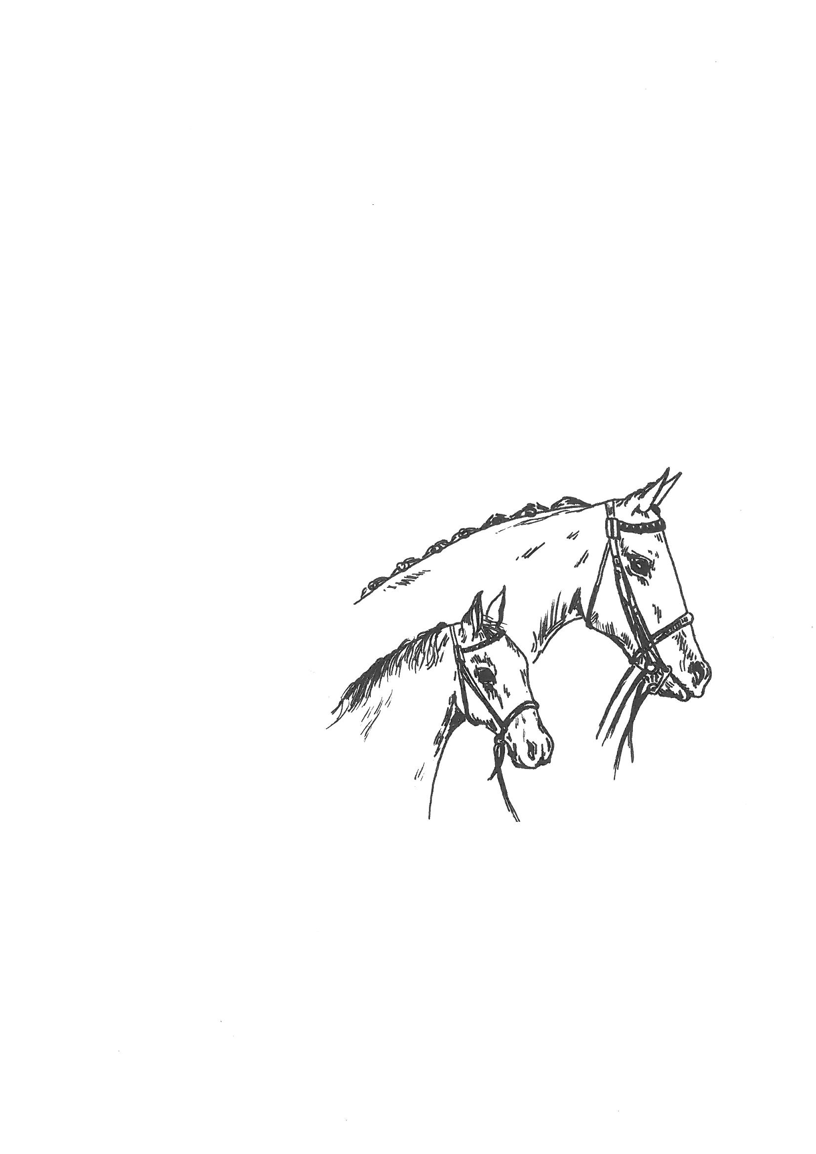

NORTHERN
COUNTIES
PONY
ASSOCIATION

Northern Spectacular Show

SUNDAY 5th OCTOBER 2025
NORTHALLERTON EQUESTRIAN CENTRE,
Yafforth, North Yorkshire, DL7 0PQ
ONLINE PRE ENTRIES ONLY NO ENTRIES ON THE DAY

ENTRIES CLOSE

Online Wednesday September 24th at standard rate &
Wednesday 1st October at +£5 increased fee

ONLINE: NCPA Members £10 Foal classes £5 Non-members £15 Foal classes £10 (Warm up classes £8/£10)

Affiliated to BSPS

Show Secretary – Mrs J Bushell
Tel: 01704 834482
Email: gensec@thencpa.co.uk
www.thencpa.co.uk
ENTRIES: Mrs J K Bushell
Tel: 01704 834482
E-mail gensec@thencpa.co.uk
RULES When entering an animal it is a condition of entry that these rules are abided by.
1. The Officials and Council of the NCPA accept no responsibility for loss, injury or damage to any person or their property whilst on the Showground, car parks or approaches. (All entries are subject to these conditions).
2. Exhibitors alone are solely responsible for the accuracy and eligibility of their entries. No entry will be accepted unless accompanied by the correct fee. In the event of an entry proving incorrect, (whether by mistake or otherwise), the entry fee will not be returned.
3. An Exhibitor may not exhibit a pony bred, sold, leased or produced by the judge, his/her immediate family or his/her employer.
4. Show canes and whips must not be more than 30 inches long.
5. Ponies must leave the ring in an orderly fashion.
6. All RIDERS must wear hats which comply to PAS 015 or Current Standard whilst mounted, whether exhibiting or not. Please see Rule 43 in the BSPS Rule & Show Handbook. BSPS WHP riders must wear back protectors.
7. Mountain and Moorland ponies must be shown in natural state.
8. Mountain and Moorland ponies must be registered with their respective Breed Society, and the registration number quoted on the entry form.
9. All Stallions and Colts must be handled/ridden by a person 12 years of age or over, and be adequately bitted and under control. The Committee reserves the right to expel from the Showground any animal not considered to be under control, especially where a danger to the public could be created.
10. No mucking out of horseboxes/trailers or litter left on the showground.
11. All Exhibitors must be wearing the allocated number for the Exhibit when entering the ring
12. Handlers MUST be appropriately dressed when entering the ring and are advised to wear a hard hat.
13. The judge’s decision is final.
14. In the event of the Show being cancelled by events beyond our control, an administration fee of£5 will be deducted from each Exhibitor.
15. Exhibitors must have public liability insurance when competing at NCPA events. The Organisers and Show Committee will take any necessary precautions to ensure the health and safety of persons on the Showground.
16. It is a condition of entry to the Showground that all persons will act on any instructions given to them by the Show Committee or ANY official, in so far that it can affect the health and safety of all. All Competitors must take due regard to the Health and Safety Act and have due regard for the safety of others. All competitors must abide by & comply with any guidelines supplied with the back numbers
**This show is a qualifier for the N.C.P.A. Pony of The Year held in September 2026. First, second & third prize winners will qualify. ** **This show is a qualifier for the N.C.P.A. GOLDEN SUPREMES held in September 2023. ALL Champions & Reserves will qualify. **
This show is a qualifier for the BSPS Winter Championship Show 2026
1st –3rd In the Winter Workers 1st- 3rd plus highest placed Junior will qualify. The highest placed 4, 5 & 6 year old in the young pony classes will qualify

RING ONE INDOORS JUDGING: 9.00 A.M. PROMPT

In Hand Judge: Mrs A McKinley

1 Coloured/Gypsy Cob any type Yearling: Colt, Filly or Gelding.
2 Coloured/Gypsy Cob any type Youngstock: Colt, Filly or Gelding 2 & 3yrs old.
3 Coloured any type/Gypsy Cob: Stallion, Mare or Gelding 4yrs and over.

4 Miniature Horse: Colt, Filly, Stallion, Mare or Gelding. Any age.

Part Bred In Hand
5 Any Part bred: Colt, Filly or Gelding any height 3 years old & under.
6 Any Part bred: Stallion, Mare or Gelding 4yrs and over, any height.

7 RP or HP: Colt, Filly or Gelding not to exc 153cms at maturity 3 years old & under.
8 RP or HP: Stallion, Mare or Gelding 4yrs and over, not to exc 153cms.

9 Hack, RH, Hunter, Cob, Race Horse/TB: Colt, Filly or Gelding to exc 148cms at maturity 3 years old & under.
10 Hack, RH, Hunter, Cob, Race Horse/TB: Stallion, Mare or Gelding 4yrs and over, exc 148cms

11 Veteran 15 years & over: Stallion, Mare or Gelding any type, any height

12 Performance animal: Any animal, any age, any height. Handler any age. To be judged 40% walk, 40% trot and 20% overall impression.
Championship: 1st & 2nd from classes 1 to 12

Foal Classes (Foal may accompany dam)

F1 Foal not to exc 143cms at maturity: Foal, any breed/type
F2 Foal to exc 143cms at maturity: Foal, any breed/type
F3 Coloured Foal: Foal, any breed/type
F4 Foal: Foal, any owner bred, any breed, any type
F5 Small Breed Foal: Dartmoor, Exmoor, Shetland, Welsh A & B.
F6 Large Breed Foal: Connemara, Dales, Fell, Highland, New Forest, Welsh C & D foal.

NCPA Registered non M&M In Hand
All animals to be registered with the NCPA (pink card to be carried in the ring) Class winners qualify for the NCPA President’s Cup 2025
13 NCPA Registered Non M&M Youngstock: yearling, 2 & 3yrs any height.
14 NCPA Registered Non M&M: Stallion, Mare or Gelding 4yrs and over any height.

***Class ER1 Open Rescue In Hand: Any age, type, breed. Mares with foal at foot are not permitted. No exhibit under the age of one year may be exhibited on its own. Qualifier for RESS final to be held at Equifest 2026

Not Before 10.30am
Mountain and Moorland Ponies In Hand Judge: Mrs L Birtwell
(All exhibits must be registered in the pure bred section of the relevant breed society)
15 Dartmoor/Exmoor/Shetland Yearling: Colt, Filly or Gelding.
16 Dartmoor/Exmoor/Shetland Youngstock: Colt, Filly or Gelding 2 & 3yrs old.
17 Welsh A & B Yearling: Colt, Filly or Gelding.
18 Welsh A & B Youngstock: Colt, Filly or Gelding 2 & 3yrs old.
19 Small Breeds: Stallion, Mare or Gelding 4yrs and over.
20 Dales/Fell/Highland Yearling: Colt, Filly or Gelding.
21 Dales/Fell/Highland Youngstock: Colt, Filly or Gelding 2 & 3yrs old.
22 Connemara/New Forest Yearling: Colt, filly or gelding.
23 Connemara/New Forest Youngstock: Colt, filly or gelding 2 & 3yrs old.
24 Welsh C & D Yearling: Colt, Filly or Gelding.
25 Welsh C & D Youngstock: Colt, Filly or Gelding 2 & 3yrs old.
26 Large Breeds: Stallion, Mare or Gelding 4yrs and over.
Championship: 1st & 2nd from classes 15 to 26

NCPA Registered M&M In Hand
(All animals to be registered with the NCPA Pink card to be carried in the ring) Class winners qualify for the NCPA President’s Cup & NCPA Reg Supreme 2026
27 NCPA Registered M&M Yearling: Colt, Filly or Gelding any breed.
28 NCPA Registered M&M Youngstock: Colt, Filly or Gelding 2 & 3yrs old any breed.
29 NCPA Registered M&M: Stallion, Mare or Gelding 4 yrs and over any breed.

Not Before 1pm Judge: Mrs J James

D1 Dales: Stallion, Mare or Gelding 4 years old & over. Foal Special
D2 Dales: Colt, Filly or Gelding Yearling, 2 & 3 years old.
D3 Dales Traditional Ridden, walk & trot only : Stallion, Mare or Gelding 4 years old & over.
D4 Dales Open Ridden: Stallion, Mare or Gelding 4 years old & over.
Dales Championship 1st & 2nd prize winners from classes D1 - D4
Judge: Mr R James
D5 Dales Pony Society Ridden Pony of the Year FINAL
Qualified Stallions, Mares and Geldings 4 years old and over.

RING TWO INDOORS 8.30AM

Ridden Judge: Mr C Grant
30 THE BSPS YOUNG HERITAGE PONY OF THE YEAR Registered Heritage Stallion, Mare or Gelding. 4, 5 or 6 yrs. old. Riders any age but must be suitably mounted for the animal they ride.
31 BSPS Heritage M & M Novice Small Breeds Ridden: Registered Pure Bred Dartmoor, Exmoor, Shetland, Welsh A & B Ponies 4yr old or over. Riders any age.
32 BSPS Heritage M & M Novice Large Breeds Ridden: Registered Pure Bred Connemara, Dales, Fell, Highland, New Forest Welsh C & D Ponies 4yr old or over. Riders any age.
33 BSPS Heritage Mountain & Moorland Open (Challenge) Small Breeds Ridden: Registered Pure Bred Dartmoor, Exmoor, Shetland, Welsh A & B Ponies 4yr old or over. Riders any age.
34 BSPS Heritage M & M Open (Challenge) Large Breeds Ridden: Pure Bred Connemara, Dales, Fell, Highland, New Forest Welsh C & D Ponies 4yr old or over. Riders any age.
Championship: 1st & 2nd from classes 30 to 34
35 BSPS Heritage M & M Novice Lead Rein: Registered Pure Bred Mare or Gelding 4yr old and over, not exc 122cm. Riders not to have attained their 9th birthday before 1st Jan in the current year.
36 BSPS Heritage M & M Open (Challenge) Lead Rein: Registered Pure Bred Mare or Gelding 4yr old and over, not exc 122cm. Riders not to have attained their 9th birthday before 1st Jan in the current year.
37 BSPS Heritage Mountain & Moorland Novice First Ridden: Registered Pure Bred Mare or Gelding 4yr old and over, not exc 128cm. Riders not to have attained their 12th birthday before 1st Jan in the current year.
38 BSPS Heritage Mountain & Moorland Open (Challenge) First Ridden: Registered Pure Bred Mare or Gelding 4yr old and over, not exc 128cm. Riders not to have attained their 12th birthday before 1st Jan in the current year. Any suitable bridle permitted.
Championship: 1st & 2nd from classes 35 to 38

Judge: Mrs A McKinley
***Class ER2 Open Rescue Ridden: Any type or breed. Can include Lead Rein and First Ridden (will not be included in the initial go round). All riders must be the appropriate height / weight for their equine Qualifier for RESS final to be held at Equifest 2026

Topline Horseboxes 2026 Junior M&M Ridden Qualifier
+J1 Junior M&M Ridden: Mare or Gelding, 4 years old over Welsh A, Welsh B, Dartmoor, Exmoor, and Shetland. Rider not to have attained their 14th birthday before 1st January in the current year.
J2 Junior M&M Ridden: Mare or Gelding 4yrs and over, Welsh C & D, Connemara, Dales, Fell, New Forest and Highland. Riders not to have attained their 18th birthday before 1st January in the current year.
NCPA Registered M&M Ridden
All animals to be registered with the NCPA (pink card to be carried in the ring). Class winners qualify for the NCPA Chairman’s Cup 2025
39 NCPA Registered Small Breeds (inc Lead Reins): Stallion, Mare or Gelding, 4yrs and over. Rider any age.
40 NCPA Registered Large Breeds: Stallion, Mare or Gelding, 4yrs and over. Rider any age.

Not Before 1pm
Judge: Mr I Dickinson
NCPA Registered Non M&M Ridden
All animals to be registered with the NCPA (pink card to be carried in the ring). Class winner qualifies for the NCPA Chairman’s Cup 2025
41 NCPA Registered Non M&M: Stallion, Mare or Gelding 4yrs and over, any height (inc Lead Rein). Rider to be suitable size for the pony.

+42 Coloured &/or Traditional Gypsy Cob: Stallion, Mare or Gelding 4 yrs old, any height.

43 Any breed/type Lead Rein Pony: Mare or Gelding, 4yrs and over, not exc 122cms. Rider not to have attained their 9th birthday before 1st January in the current year.
44 Any breed/type First Ridden Pony: Mare or Gelding, 4yrs and over, not exc 128cms. Rider not to have attained 12th birthday before 1st January in the current year.

45 Any breed/type/height Walk Trot: Stallion, mare or gelding.
46 Any breed/type Ridden Pony: Stallion, mare or Gelding, 4yrs and over, not exc 148cms.

47 THE BSPS YOUNG SHOW PONY OF THE YEAR Mare of Gelding Show Pony 4, 5 or 6 yrs. old not exceeding 148cms. Riders any age, but must be suitably mounted for the animal they ride
48 BSPS Mixed Height Novice Show Pony: Mare or Gelding, 4yrs old and over, not exc 148cms Riders must be the correct age for the pony they ride
49 BSPS Mixed Height Open (Challenge) Show Pony: Mare or Gelding 4yrs and over, not exc 148cms Riders must be the correct age for the pony they ride.

50 THE BSPS YOUNG SHOW HUNTER PONY OF THE YEAR Mare or Gelding Show Hunter Pony 4, 5 or 6 yrs. old not exceeding 153cms. Riders any age, but must be suitably mounted for the animal they ride.
51 BSPS Mixed Height Novice Show Hunter Pony: Mare or Gelding 4yrs and over, not exc 153cms. Riders must be the correct age for the pony they ride.
52 BSPS Mixed Height Open (Challenge) Show Hunter Pony: Mare or Gelding 4yrs and over, not exc 153cms. Riders must be the correct age for the pony they ride.
53 THE BSPS YOUNG INTERMEDIATE OF THE YEAR Mare or Gelding Intermediate 4, 5 or 6 yrs. old not exceeding 160cms. Riders any age but must be suitably mounted for the animal they ride
54 BSPS Mixed Novice Intermediate Show Riding Type/Show Hunter Type: Mare or Gelding, 4 years old and over, exc 146cms, not exc 160cms. Riders not to have attained their 25th birthday before 1st January in the current year.
55 BSPS Mixed Open (Challenge) Intermediate Show Riding Type/Show Hunter Type: Mare or Gelding, 4 years old and over, exc 146cms, not exc 160cms. Riders not to have attained their 25th birthday before 1st January in the current year.

56 Hunter/Cob/Hack/Riding Horse/Race Horse/TB: Mare or Gelding exc 148cms. Judge will not ride.
Championship: 1st & 2nd from classes 47 to 56

RING THREE (OUTDOORS) 9.00AM Judge: Mr D Dixon

57 Warm Up 50cms Animals 4 years old or over. Riders any age.
No Marks No Rosettes

58 Lead Rein WHP: Mare or Gelding, any breed, any type 4 yrs old or over not exc 122cm. Riders not to have attained their 9th birthday before 1st Jan of the current year.
59 BSPS Open Cradle Stakes: Mare or Gelding, 4 yrs old or over not exc 123cm Riders not to have attained their 11th birthday before 1st Jan of the current year.
60 BSPS Open (Challenge) Nursery Stakes: Mare or Gelding, 4 yrs old or over not exc 133cm Riders not to have attained their 12th birthday before 1st Jan of the current year.
Championship: 1st & 2nd from classes 58 - 60

Judge: Mr D Dixon

61 60cms BSPS Winter Worker Stakes: Plaited or Heritage M&M ponies, 4 years old & over not exc 158cms. Riders any age but must be suitably mounted for the pony/horse they ride. An award card for the highest placed child under 12 years of age on the day of the show who will also qualify for the BSPS Winter Championships.

62 70cms BSPS Winter Worker Stakes: Plaited or Heritage M&M ponies, 4 years old & over not exc 158cms. Riders any age but must be suitably mounted for the pony/horse they ride. An award card for the highest placed child under 14 years of age on the day of the show who will also qualify for the BSPS Winter Championships.

63 80cms BSPS Winter Worker Stakes: Plaited or Heritage M&M ponies, 4 years old & over not exc 158cms. Riders any age but must be suitably mounted for the pony/horse they ride. An award card for the highest placed child under 18 years of age on the day of the show who will also qualify for the BSPS Winter Championships.

64 90cms BSPS Winter Worker Stakes: Plaited or Heritage M&M ponies, 4 years old & over not exc 158cms. Riders any age but must be suitably mounted for the pony/horse they ride. An award card for the highest placed child under 18 years of age on the day of the show who will also qualify for the BSPS Winter Championships.

65 100cms BSPS Winter Worker Stakes: Plaited or Heritage M&M ponies, 4 years old & over not exc 158cms. Riders any age but must be suitably mounted for the pony/horse they ride. An award card for the highest placed child under 25 years of age on the day of the show who will also qualify for the BSPS Winter Championships.

66 Horse Workers: Mare or gelding 4 years old & over exc 148cms. Riders any age. Fences not exc 90cms

